DOCTORS  Partners:  Surjit Kailey MB BS DA DCh - Qualified - London 1985  Mohan Ghosh MB ChB JCPTGP- Qualified - Dundee 1986  Daniel Aderinto MB BS MRCP DCH DGM -  Qualified - Nigeria 1986  Salaried GP’s:  Sunila Dhaduvai MBBS, DFSRH, DRCOG -  Qualified - Karnataka 1992  Chris Bennett-Britton MB ChB - Qualified - Sheffield 2010  Sherina Saju MBBS, MRCP, MRCGP, DRCOG, DFSRH -  Qualified - India 2003  Anish Gurung – MB BS – Qualified – Tianjin 2009  Ranjeev Salh – MB BS – Qualified – London 2013  Management  Helen Hatfield, Practice Manager.  Sue Flanagan, Strategic & Business Manager.  Beverly Russell, Operations & Finance Manager.  Advanced Nurse Practitioner  Regina Boyle RGN, RM is fully qualified to diagnose and treat patients.  Practice Nurses  Veronica Stocker RGN, Harriet Vuvor RGN can give advice on many matters including; health promotion, child immunisations, travel medicine, family planning, cervical smears, weight, chronic disease management and blood pressure.  Nurse Associate  Emma Pickard  Perform new-patient medicals and nursing procedures including, ECG, diabetic checks, cervical smears, Learning Disability checks and wound care.  Health Care Assistants  Maria Veronica Warren and Emma Ridley  Perform new-patient medicals and basic nursing procedures like blood pressure checks and weight loss advice.  Clinical Pharmacists  Priya Mistry and Ramat Popoola  They are qualified experts in medicines. They can help manage long term conditions, give advice for those on multiple medicines and provide structured medication reviews. Their role is pivotal to improving quality of care and ensuring patient safety. |  | Receptionists and Administration  Reception: Gina, Mary, Julie, Caroline,  Teresa, Pat, Laura, Belinda, Sarah, Madeline & Poppy.  Have a difficult job to do with phone calls and enquiries  from every direction. When telephoning for medical attention they have been trained to ask you for some  details, so that they can help in the most appropriate way.  Administration: Sarah, Molly, Elaine, Jessica, Nikki, Sue, Kerrie, Gurjeevan, Carolyn & Kate.  PATIENTS WITH PARTICULAR NEEDS  The Practice has disabled access, parking and disabled  toilet facilities, baby changing facilities are also available.  We can arrange interpretation for patients who do not  speak English. Please let us know if you need this service  when booking an appointment.  PATIENT CONFIDENTIALITY  The Practice is committed to respecting and protecting all patient records and all patient identifiable data held by the Practice. We have practices and policies in place to  safeguard your personal information. We comply with the Data Protection Act and the Access to Records Act. We will ensure that all medical records are kept confidential and secure. All staff are bound by the same strict code of confidentiality.  Patients requiring access to their medical records may do so  by putting the request in writing to the Practice Manager.  We run a Patient Participation Group. If you would you like  to become more involved with the Practice, help improve services, support Practice development or help communicate  to other patients, please email us at: northumberlandheath.medicalcentre@nhs.net _________________________________________________  We are an NHS PMS Practice in contract with:  NHS South East London ICB (Bexley)  2nd Floor West, 2 Watling Street  Bexleyheath,  Kent  DA6 7AT  0208 176 5330  FEB 2023 |  | NORTHUMBERLAND HEATH  MEDICAL CENTRE  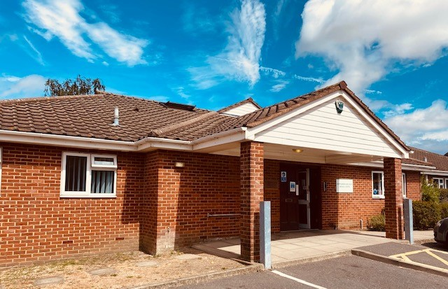  Hind Crescent, Erith, Kent DA8 3DB  O1322 336556  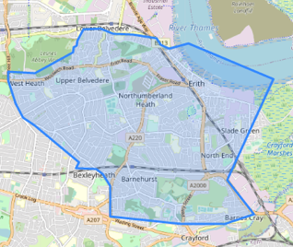  Dr Surjit Kailey, Dr Mohan Ghosh  Dr Daniel Aderinto, Dr Sunila Dhaduvai,  Dr Chris Bennett-Britton, Dr Anish Gurung  Dr Sherina Saju, Dr Ranjeev Salh  Visit our Website at: www.northumberlandheathmedicalcentre.co.uk
Practice Opening Hours  The reception staff are available Monday to Friday between 8.00am and 6.30pm to make your appointments by telephone or in person. You can request an appointment with the GP of your choice, but you may have to wait longer if that GP is already booked.  If you need to be seen that day for a medically urgent problem make this clear to the receptionist, and you will be given an appointment time.  AskFirst  AskFirst is a new app to help patients get the right healthcare they need at the right time. The AskFirst app is free to download and offers digital access to the GP practice. You can book routine appointments, urgent appointments via the symptom checker, self-care advice, cancel/amend appointments and book health reviews.  Online Booking  You can now register to make, change or cancel an appointment, advise us of a change of address and request a routine repeat prescription via the internet at a time that is convenient to you. Please ask at reception for a Registration Letter then follow the instructions on the Patient Access website.  Consulting Times  Monday to Friday; surgeries are held, by appointment only, throughout the day between 8.00am and 6.00pm, we have extended appointments on with a GP, Nurse Practitioner and Practice Nurse from 7.00am on a Monday and Thursday. The surgery times for individual GP’s vary each day.  Emergencies  Medical emergencies will be dealt with as soon as possible. Always use the 01322 336556 number. If you need medical assistance outside of surgery hours please telephone 111.  Home Visits  Home visits are for the housebound, or for those whose illness itself prevents them from attending the Practice. Home visits can only be carried out when the GP considers the medical condition of the patient makes this necessary. Generally this would be when travel to the Practice by car or taxi would endanger the patient’s health. Adequate parking and a taxi “drop-off” point are available at the Practice.  If you think you may need a home visit please try to phone between 8.30am and 10.30am where possible. | Services available  - Childhood Immunisations  - Travel Vaccinations (fee may be payable)  - Ante-Natal Clinics, with Midwife  - Weight Reduction  - Well Person Assessment  - Family Planning including implants & Coils  - Chronic Disease Management;  Coronary Heart Disease & Hypertension  Asthma & Chronic Obstructive Airways Disease  Diabetes, Thyroid disorders, Epilepsy, Stroke.  Registration  Patients wishing to register with the Practice will be asked to complete a New Patient Registration Form and will be asked to attend for a New Patient Medical Examination. This will help the Practice to record information about your health and medical history which could be important if you needed to see a GP before your old records become available.  Violent or Abusive Patients  We subscribe to the NHS Zero-tolerance policy if a patient is violent or abusive to any Practice member, or other persons on the Practice premises. Such patients will be removed from the Practice list and in cases of violence or threatening behaviour the Police will be called. The reasons for removal will be given in writing  Complaints  Offering the best service is a mutual concept. It is the responsibility of patients to co-operate with the health care professionals by taking offered advice, keeping appointments and generally considering others when using the Practice.  If you have a complaint, concern or comment about any aspect of the services provided by the Practice, please bring it to the attention of the Practice Manager. The Practice follows an accredited complaints procedure. |  | Repeat Prescriptions  Patients on regular medication may be offered repeat prescriptions. Repeat prescriptions are computerised and each time a new prescription is written a new repeat prescription request form will be attached.  For medico-legal and safety reasons, prescription requests cannot be taken over the phone.  Please allow two working days for your prescription, tick which items you require on the repeat prescription request form.  Please try to order all of your prescription items together.  You can collect your prescription from the Practice, or it can be posted to you if you enclose a stamped addressed envelope, or it can go electronically to a chemist of your choice.  Please do not add unauthorised items to your repeat request slip as this causes delays.  Sickness Certificates  You should not require a doctor’s certificate for any illness lasting 7 days or less. Your employer may require you to complete a self-certificate (SC1) which is available from your employer, post office, DSS or the surgery. If you need a certificate for illness lasting more than 7 days, you will need to see a GP and an appointment should be made as soon as possible.  If your employer insists on a note for a work absence during the first 7 days, the GP may agree but a fee will be charged.  Non NHS Medical Services  If you need a special examination or report for insurance, holiday, driving, employment, sports or other reasons, this can be arranged through reception. This work is not covered by the NHS and a list of these services and fees is available from reception. Some reports can take up to 3 weeks to be completed.

